
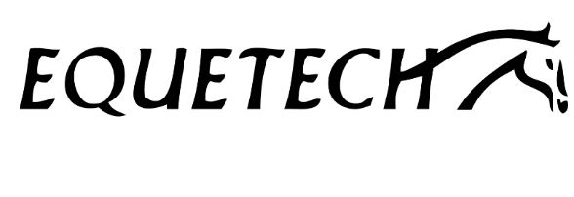

British Riding Clubs
Equetech Dressage to Music
Qualifier Entry Form
(Part of the Winter Dressage Championships held between 24 – 26 April 2026 at Arena UK, Allington Lane, Allington, Grantham, NG32 2EF)

Riding Club ……………………………………..

Class Name | Test | Rider | Membership Number | Horse | Competition Pass (Y/N)
Junior Prelim Dressage to Music | BD Prelim Freestyle to Music (2016)
Junior Novice Dressage to Music | BD Novice Freestyle to Music (2019)
Mixed Pairs Dressage to Music | BRC Novice Pairs Dressage to Music (2018)
Senior Prelim Dressage to Music | BD Prelim Freestyle to Music (2016)
Senior Novice- 0 Points- Dressage to Music | BD Novice Freestyle to Music (2019)
Senior Novice- with Points- Dressage to Music | BD Novice Freestyle to Music (2019)
Elementary Dressage to Music (Mixed) | BD Elementary Freestyle to Music (2024)
Pick a Test Dressage to Music  Medium/Advanced Medium | BD Medium Freestyle to Music (2016) or BD Advanced Medium Freestyle to Music (2016)


RIDE TOGETHER • TRAIN TOGETHER • COMPETE TOGETHER • HAVE FUN TOGETHER

RIDE TOGETHER • TRAIN TOGETHER • COMPETE TOGETHER • HAVE FUN TOGETHER

